 |  | E  TG/28/9 Corr.  ORIGINAL: English  DATE: 2009-04-01 + 2009-10-27
INTERNATIONAL UNION FOR THE PROTECTION OF NEW VARIETIES OF PLANTS
GENEVA

 | ZONAL PELARGONIUM, IVY-LEAVED PELARGONIUM  UPOV Code: PELAR_ZON, PELAR_PEL  (PELAR_PZO, PELAR_ZPE, PELAR_ZTO)  Pelargonium Zonale Group, Pelargonium peltatum (L.) Hér.  and hybrids between those species and other species of  Pelargonium L'Hér. ex Ait. | *

GUIDELINES

FOR THE CONDUCT OF TESTS

FOR DISTINCTNESS, UNIFORMITY AND STABILITY

Alternative Names:*

Botanical name | English | French | German | Spanish
Pelargonium Zonale Group,  Pelargonium ×hortorum L. H. Bailey,  Pelargonium-Zonale-Hybridae | Zonal Pelargonium, Horseshoed pelargonium | Géranium, Pelargonium zonale | Zonal-Pelargonie | Geranio zonal, geranio malvón, geranio de hierro, geranio de sardina, pelargonio
Pelargonium peltatum (L.) Hér.,  Pelargonium-Peltatum-Hybridae | Ivy-leaved Pelargonium,  Hanging geranium,  Ivy geranium,  Ivy-leaf pelargonium | Géranium lierre | Efeupelargonie, Efeublättrige Pelargonie

The purpose of these guidelines (“Test Guidelines”) is to elaborate the principles contained in the General Introduction (document TG/1/3), and its associated TGP documents, into detailed practical guidance for the harmonized examination of distinctness, uniformity and stability (DUS) and, in particular, to identify appropriate characteristics for the examination of DUS and production of harmonized variety descriptions.

ASSOCIATED DOCUMENTS

These Test Guidelines should be read in conjunction with the General Introduction and its associated TGP documents.

TABLE OF CONTENTS PAGE

1. Subject of these Test Guidelines 3
2. Material Required 3
3. Method of Examination 3
3.1 Number of Growing Cycles 3
3.2 Testing Place 3
3.3 Conditions for Conducting the Examination 3
3.4 Test Design 4
3.5 Number of Plants / Parts of Plants to be Examined 4
3.6 Additional Tests 4
4. Assessment of Distinctness, Uniformity and Stability 4
4.1 Distinctness 4
4.2 Uniformity 5
4.3 Stability 5
5. Grouping of Varieties and Organization of the Growing Trial 5
6. Introduction to the Table of Characteristics 6
6.1 Categories of Characteristics 6
6.2 States of Expression and Corresponding Notes 6
6.3 Types of Expression 6
6.4 Example Varieties 7
6.5 Legend 7
7. Table of Characteristics/Tableau des caractères/Merkmalstabelle/Tabla de caracteres 8
8. Explanations on the Table of Characteristics 22
8.1 Explanations covering several characteristics 22
8.2 Explanations for individual characteristics 22
9. Literature 30
10. Technical Questionnaire 31

Subject of these Test Guidelines
These Test Guidelines apply to all varieties of Pelargonium Zonale Group (syn. Pelargonium x hortorum L.H. Bailey) and Pelargonium peltatum (L.) Hér. as well as to hybrids between these species and other species of Pelargonium L'Hér. ex Aiton of the family Geraniaceae.

Material Required
2.1 The competent authorities decide on the quantity and quality of the plant material required for testing the variety and when and where it is to be delivered. Applicants submitting material from a State other than that in which the testing takes place must ensure that all customs formalities and phytosanitary requirements are complied with.

2.2 The material is to be supplied in the form of well-rooted cuttings that have not been pinched, or seeds.

2.3 The minimum quantity of plant material, to be supplied by the applicant, should be:

vegetatively propagated varieties: 15 well-rooted cuttings that have not been pinched
seed-propagated varieties: sufficient seed to produce 30 plants

2.4 The plant material supplied should be visibly healthy, not lacking in vigor, nor affected by any important pest or disease.

2.5 The plant material should not have undergone any treatment which would affect the expression of the characteristics of the variety, unless the competent authorities allow or request such treatment. If it has been treated, full details of the treatment must be given.

Method of Examination

3.1 Number of Growing Cycles
The minimum duration of tests should normally be a single growing cycle.

3.2 Testing Place
Tests are normally conducted at one place. In the case of tests conducted at more than one place, guidance is provided in TGP/9 “Examining Distinctness”.

3.3 Conditions for Conducting the Examination
3.3.1 The tests should be carried out under conditions ensuring satisfactory growth for the expression of the relevant characteristics of the variety and for the conduct of the examination.

3.3.2 The optimum stage of development for the assessment of the characteristics is at the time of full flowering.

3.3.3 Because daylight varies, color determinations made against a color chart should be made either in a suitable cabinet providing artificial daylight or in the middle of the day in a room without direct sunlight. The spectral distribution of the illuminant for artificial daylight should conform with the CIE Standard of Preferred Daylight D 6500 and should fall within the tolerances set out in the British Standard 950, Part I. These determinations should be made with the plant part placed against a white background.

3.4 Test Design
3.4.1 Vegetatively propagated varieties: each test should be designed to result in a total of at least 15 plants.

3.4.2 Seed-propagated varieties: each test should be designed to result in a total of at least 30 plants.

3.4.3 The design of the tests should be such that plants or parts of plants may be removed for measurement or counting without prejudice to the observations which must be made up to the end of the growing cycle.

3.5 Number of Plants / Parts of Plants to be Examined
3.5.1 Vegetatively propagated varieties: unless otherwise indicated, all observations on single plants should be made on 10 plants or parts taken from each of 10 plants and any other observations made on all plants in the test.

3.5.2 Seed propagated varieties: unless otherwise indicated, all observations on single plants should be made on 20 plants or parts taken from each of 20 plants and any other observations made on all plants in the test.

3.6 Additional Tests
Additional tests, for examining relevant characteristics, may be established.

Assessment of Distinctness, Uniformity and Stability

4.1 Distinctness

4.1.1 General Recommendations

It is of particular importance for users of these Test Guidelines to consult the General Introduction prior to making decisions regarding distinctness. However, the following points are provided for elaboration or emphasis in these Test Guidelines.

4.1.2 Consistent Differences

The differences observed between varieties may be so clear that more than one growing cycle is not necessary. In addition, in some circumstances, the influence of the environment is not such that more than a single growing cycle is required to provide assurance that the differences observed between varieties are sufficiently consistent. One means of ensuring that a difference in a characteristic, observed in a growing trial, is sufficiently consistent is to examine the characteristic in at least two independent growing cycles.

4.1.3 Clear Differences

Determining whether a difference between two varieties is clear depends on many factors, and should consider, in particular, the type of expression of the characteristic being examined, i.e. whether it is expressed in a qualitative, quantitative, or pseudo-qualitative manner. Therefore, it is important that users of these Test Guidelines are familiar with the recommendations contained in the General Introduction prior to making decisions regarding distinctness.

4.2 Uniformity
4.2.1 It is of particular importance for users of these Test Guidelines to consult the General Introduction prior to making decisions regarding uniformity. However, the following points are provided for elaboration or emphasis in these Test Guidelines:

4.2.2 For the assessment of uniformity of vegetatively propagated varieties a population standard of 1% and an acceptance probability of at least 95% should be applied. In the case of a sample size of 15 plants, 1 off-type is allowed.

4.2.3 For the assessment of uniformity of seed-propagated varieties, the recommendations in the General Introduction for self-pollinated, cross-pollinated or hybrid varieties should be followed, as appropriate.

4.3 Stability
4.3.1 In practice, it is not usual to perform tests of stability that produce results as certain as those of the testing of distinctness and uniformity. However, experience has demonstrated that, for many types of variety, when a variety has been shown to be uniform, it can also be considered to be stable.

4.3.2 Where appropriate, or in cases of doubt, stability may be tested, either by growing a further generation, or by testing a new seed or plant stock to ensure that it exhibits the same characteristics as those shown by the previous material supplied.

Grouping of Varieties and Organization of the Growing Trial
5.1 The selection of varieties of common knowledge to be grown in the trial with the candidate varieties and the way in which these varieties are divided into groups to facilitate the assessment of distinctness are aided by the use of grouping characteristics.

5.2 Grouping characteristics are those in which the documented states of expression, even where produced at different locations, can be used, either individually or in combination with other such characteristics: (a) to select varieties of common knowledge that can be excluded from the growing trial used for examination of distinctness; and (b) to organize the growing trial so that similar varieties are grouped together.

5.3 Besides the botanical species the following have been agreed as useful grouping characteristics:

(a) Leaf blade: variegation (characteristic 12)
(b) Leaf blade: main color (zone excluded) (characteristic 13)
(c) Flower: type (characteristic 29)
(d) Upper petal: type of marking (characteristic 45)
(e) Lower petal: color of middle of upper side (characteristic 52) with the following groups:
Gr. 1: white
Gr. 2: orange pink
Gr. 3: orange
Gr. 4: red
Gr. 5: purple
Gr. 6: blue pink

5.4 Guidance for the use of grouping characteristics, in the process of examining distinctness, is provided through the General Introduction.

Introduction to the Table of Characteristics

6.1 Categories of Characteristics
6.1.1 Standard Test Guidelines Characteristics

Standard Test Guidelines characteristics are those which are approved by UPOV for examination of DUS and from which members of the Union can select those suitable for their particular circumstances.

6.1.2 Asterisked Characteristics

Asterisked characteristics (denoted by *) are those included in the Test Guidelines which are important for the international harmonization of variety descriptions and should always be examined for DUS and included in the variety description by all members of the Union, except when the state of expression of a preceding characteristic or regional environmental conditions render this inappropriate.

6.2 States of Expression and Corresponding Notes
States of expression are given for each characteristic to define the characteristic and to harmonize descriptions. Each state of expression is allocated a corresponding numerical note for ease of recording of data and for the production and exchange of the description.

6.3 Types of Expression
An explanation of the types of expression of characteristics (qualitative, quantitative and pseudo-qualitative) is provided in the General Introduction.

6.4 Example Varieties
Where appropriate, example varieties are provided to clarify the states of expression of each characteristic.

6.5 Legend
(*) Asterisked characteristic – see Chapter 6.1.2

QL Qualitative characteristic – see Chapter 6.3
QN Quantitative characteristic – see Chapter 6.3
PQ Pseudo-qualitative characteristic – see Chapter 6.3

(a)-(c) See Explanations on the Table of Characteristics in Chapter 8.1.
(+) See Explanations on the Table of Characteristics in Chapter 8.2.

Table of Characteristics/Tableau des caractères/Merkmalstabelle/Tabla de caracteres
 |  | English | français | deutsch | español | Example Varieties  Exemples  Beispielssorten  Variedades ejemplo | Note/  Nota
1.  (*)  (+) |  | Plant: growth type | Plante : type de croissance | Pflanze: Wuchstyp | Planta: tipo de crecimiento
PQ |  | upright | dressée | aufrecht | erguida | Sil Merle | 1
 |  | semi-upright | demi-dressée | halbaufrecht | semierguida | Cante Laver | 2
 |  | trailing | étalée | hängend | rastrera | KLEP04112 | 3
2. |  | Only varieties with growth type: upright or semi-upright: Plant: height of foliage | Seulement variétés avec type de croissance : dressée ou demi-dressée : Plante : hauteur du feuillage | Nur Sorten mit Wuchstyp: aufrecht oder halbaufrecht : Pflanze: Höhe der Laubzone | Sólo variedades con tipo de crecimiento: erguida o semierguida: Planta: altura del follaje
QN |  | short | bas | niedrig | baja | Sil Merle | 3
 |  | medium | moyen | mittel | media | Fisum Pink | 5
 |  | tall | haut | hoch | alta | Zowitre | 7
3. |  | Only varieties with growth type: trailing:  Plant: shoot length | Seulement variétés avec type de croissance : étalée: Plante : longueur de la tige | Nur Sorten mit Wuchstyp: hängend:  Pflanze: Trieblänge | Sólo variedades con tipo de crecimiento rastrera:  Planta: longitud de la rama
QN |  | short | courte | kurz | corta | Free Rured | 3
 |  | medium | moyenne | mittel | media | Pacameli | 5
 |  | long | longue | lang | larga | KLEP04112 | 7
4. |  | Only varieties with growth type: upright or semi-upright:  Plant: width | Seulement variétés avec type de croissance : dressée ou demi-dressée : Plante : largeur | Nur Sorten mit Wuchstyp: aufrecht oder halbaufrecht : Pflanze: Breite | Sólo variedades con tipo de crecimiento: erguida o semierguida:  Planta: anchura
QN |  | narrow | étroite | schmal | estrecha | Zolcaros | 3
 |  | medium | moyenne | mittel | media | Zolarlet | 5
 |  | broad | large | breit | ancha | Pacsalpri | 7
5. |  | Stem: color (excluding anthocyanin) | Tige : couleur (anthocyane exclu) | Trieb: Farbe (ohne Anthocyan) | Tallo: color (excluida la antocianina)
QL | (a) | whitish | blanchâtre | weißlich | blanquecino |  | 1
 |  | green | verte | grün | verde |  | 2
6. |  | Stem: anthocyanin coloration | Tige : pigmentation anthocyanique | Trieb: Anthocyanfärbung | Tallo: pigmentación antociánica
QN | (a) | absent or very weak | absente ou très faible | fehlend oder sehr gering | ausente o muy débil | KLEP03012 | 1
 |  | medium | moyenne | mittel | media | Fisrocky Dark Red | 3
 |  | strong | forte | stark | fuerte | Balgaldepro | 5
7.  (*)  (+) |  | Leaf blade: length | Limbe : longueur | Blattspreite: Länge | Limbo: longitud
QN | (a) | short | court | kurz | corta | KLEP03012 | 3
 |  | medium | moyen | mittel | media | Zolirsca | 5
 |  | long | long | lang | larga | Pacvica | 7
8.  (*) (+) |  | Leaf blade: width | Limbe : largeur | Blattspreite: Breite | Limbo: anchura
QN | (a) | narrow | étroit | schmal | estrecha | KLEP03012 | 3
 |  | medium | moyen | mittel | media | Zolirsca | 5
 |  | broad | large | breit | ancha | Pacvica | 7
9.  (+) |  | Leaf blade: depth of sinus | Limbe : profondeur du sinus | Blattspreite: Tiefe der Einbuchtungen | Limbo: profundidad de los senos
QN | (a) | absent or very shallow | absent ou peu profond | fehlend oder sehr flach | ausente o muy poco profunda |  | 1
 |  | shallow | peu profond | flach | poco profunda | Zolcaros | 3
 |  | medium | moyen | mittel | media | KLEP01052 | 5
 |  | deep | profond | tief | profunda | Cante Laver | 7
10. |  | Leaf blade: undulation of margin | Limbe : ondulation du bord | Blattspreite: Randwellung | Limbo: ondulación del borde
QN | (a) | weak | faible | gering | débil | Zolirsca | 3
 |  | medium | moyenne | mittel | media | Zolarlet | 5
 |  | strong | forte | stark | fuerte | Wesvilsu | 7
11.  (+) |  | Leaf blade: base | Limbe : base | Blattspreite: Basis | Limbo: base
QN | (a) | wide open | très ouverte | weit offen | muy abierta |  | 1
 |  | slightly open | peu ouverte | etwas offen | ligeramente abierta |  | 3
 |  | closed | fermée | geschlossen | cerrada |  | 5
 |  | partly overlapping | à lobes peu chevauchants | gering überlappend | parcialmente solapada |  | 7
 |  | strongly overlapping | à lobes très chevauchants | stark überlappend | fuertemente solapada |  | 9
12. (*) |  | Leaf blade: variegation | Limbe : panachure | Blattspreite: Panaschierung | Limbo: variegación
QL | (a) | absent | absente | fehlend | ausente | Sil Merle | 1
 |  | present | présente | vorhanden | presente | Penevro | 9
13.  (*)  (+) |  | Leaf blade: main color (zone excluded) | Limbe : couleur principale (zone exclue) | Blattspreite: Hauptfarbe (ohne Zone) | Limbo: color principal (excluida la zona)
PQ | (a) | yellow | jaune | gelb | amarillo |  | 1
 |  | light green | vert clair | hellgrün | verde claro |  | 2
 |  | light green to medium green | vert clair à vert moyen | hellgrün bis mittelgrün | verde claro a verde medio | Zowit | 3
 |  | medium green | vert moyen | mittelgrün | verde medio | Sil Merle | 4
 |  | medium green to dark green | vert moyen à vert foncé | mittelgrün bis dunkelgrün | verde medio a verde oscuro | KLEP03106 | 5
 |  | dark green | vert foncé | dunkelgrün | verde oscuro | Zolirsca | 6
 |  | dark red | rouge foncé | dunkelrot | rojo oscuro | Vancouver Centennial | 7
 |  | brown purple | pourpre brun | braunpurpurn | púrpura marrón | Black Magic | 8
14.  (*)  (+) |  | Leaf blade: secondary color (zone excluded) | Limbe : couleur secondaire (zone exclue) | Blattspreite: Sekundärfarbe (ohne Zone) | Limbo: color secundario (excluida la zona)
PQ | (a) | white | blanc | weiß | blanco | Evka, Penevro | 1
 |  | yellow | jaune | gelb | amarillo | Raimu Kissu | 2
 |  | light green | vert clair | hellgrün | verde claro | Vancouver Centennial | 3
 |  | medium green | vert moyen | mittelgrün | verde medio | Black Magic | 4
15. |  | Only varieties with growth type: trailing: Leaf blade: glossiness | Seulement variétés avec type de croissance : étalée: Limbe : brillance | Nur Sorten mit Wuchstyp: hängend: Blattspreite: Glanz | Sólo variedades con tipo de crecimiento rastrera: Limbo: brillo
QN | (a) | weak | faible | gering | débil | Free Rured | 3
 |  | medium | moyenne | mittel | medio | Zopihosd | 5
 |  | strong | forte | stark | fuerte | KLEP04112 | 7
16.  (*)  (+) |  | Leaf blade: conspicuousness of zone | Limbe : netteté de la zone | Blattspreite: Ausprägung der Zone | Limbo: visibilidad de la zona
QN | (a) | absent or very weak | nulle ou très faible | fehlend oder sehr gering | ausente o muy débil | Zowit | 1
 |  | weak | faible | gering | débil | Zolirsca | 3
 |  | medium | moyenne | mittel | media | Zolarlet | 5
 |  | strong | forte | stark | fuerte | Pascalpri | 7
 |  | very strong | très forte | sehr stark | muy fuerte | Baldescarim | 9
17.  (+) |  | Leaf blade: position of zone | Limbe : position de la zone | Blattspreite: Position der Zone | Limbo: posición de la zona
QN | (a) | towards base | vers la base | zur Basis hin | hacia la base |  | 1
 |  | in middle | à la partie centrale | in der Mitte | en el medio |  | 2
 |  | towards margin | vers le bord | zum Rand hin | hacia el borde |  | 3
18.  (+) |  | Leaf blade: relative size of zone | Limbe : taille relative de la zone | Blattspreite: relative Größe der Zone | Limbo: tamaño relativo de la zona
QN | (a) | small | petite | klein | pequeño |  | 1
 |  | medium | moyenne | mittel | media |  | 3
 |  | large | grande | groß | grande |  | 5
19. |  | Peduncle: length | Pédoncule : longueur | Blütenstandsstiel: Länge | Pedúnculo: longitud
QN | (b) | short | court | kurz | corta | Duefuerto | 3
 |  | medium | moyen | mittel | media | Sil Merle | 5
 |  | long | long | lang | larga | Fisroweiss | 7
20.  (*)  (+) |  | Peduncle: anthocyanin coloration of middle third | Pédoncule : pigmentation anthocyanique du tiers central | Blütenstandsstiel: Anthocyanfärbung des mittleren Drittel | Pedúnculo: pigmentación antociánica en el tercio medio
QN | (b) | absent or very weak | nulle ou très faible | fehlend oder sehr gering | ausente o muy débil | Zowit | 1
 |  | weak | faible | gering | débil | Realcastor | 3
 |  | medium | moyenne | mittel | media | Gentreo | 5
 |  | strong | forte | stark | fuerte | Clips Scarl | 7
21.  (+) |  | Inflorescence: height | Inflorescence : hauteur | Blütenstand: Höhe | Inflorescencia: altura
QN | (b) | short | basse | niedrig | baja | Pacbla | 3
 |  | medium | moyenne | mittel | media | Fisrowi | 5
 |  | tall | haute | hoch | alta | Fisrocky Dark Red | 7
22.  (*)  (+) |  | Inflorescence: width | Inflorescence : largeur | Blütenstand: Breite | Inflorescencia: anchura
QN | (b) | narrow | étroite | schmal | estrecha | KLEP01052 | 3
 |  | medium | moyenne | mittel | media | KLEP03106 | 5
 |  | broad | large | breit | ancha | Zolirsca | 7
23.  (+) |  | Inflorescence: number of open flowers | Inflorescence : nombre de fleurs épanouies | Blütenstand: Anzahl offener Blüten | Inflorescencia: número de flores abiertas
QN | (b) | few | petit | gering | pocas | Tikvio | 3
 |  | medium | moyen | mittel | medio | KLEP01052 | 5
 |  | many | grand | hoch | muchas | KLEP03106 | 7
24.  (*)  (+) |  | Inflorescence: length of largest flower | Inflorescence : longueur de la fleur la plus grande | Blütenstand: Länge der größten Blüte | Inflorescencia: longitud de la flor más grande
QN | (b) | short | courte | kurz | corta | Genvired | 3
 |  | medium | moyenne | mittel | media | Genam | 5
 |  | long | longue | lang | larga | Fislunova | 7
25.  (*)  (+) |  | Inflorescence: width of largest flower | Inflorescence : largeur de la fleur la plus grande | Blütenstand: Breite der größten Blüte | Inflorescencia: anchura de la flor más grande
QN | (b) | narrow | étroite | schmal | estrecha |  | 3
 |  | medium | moyenne | mittel | media | Fisum Pink | 5
 |  | broad | large | breit | ancha | Fisroweiss | 7
26. |  | Inflorescence: length of longest pedicel | Inflorescence : longueur du pédicelle le plus long | Blütenstand: Länge des längsten Blütenstiels | Inflorescencia: longitud del pedicelo más largo
QN | (b) | short | court | kurz | corta | Cante Dereds | 3
 |  | medium | moyen | mittel | media | Fisum Pink | 5
 |  | long | long | lang | larga | Zoldarobo | 7
27. |  | Pedicel: anthocyanin coloration of upper third | Pédicelle : pigmentation anthocyanique du tiers supérieur | Blütenstiel: Anthocyanfärbung im oberen Drittel | Pedicelo: pigmentación antociánica del tercio superior
QN | (b) | absent or very weak | absente ou très faible | fehlend oder sehr gering | ausente o muy débil |  | 1
 |  | weak | faible | gering | débil | Paclai | 3
 |  | medium | moyenne | mittel | media | Fisrocky Dark Red | 5
 |  | strong | forte | stark | fuerte | Zonabriscal | 7
 |  | very strong | très forte | sehr stark | muy fuerte | Clip Velred | 9
28.  (+) |  | Pedicel: swelling | Pédicelle : renflements | Blütenstiel: Verdickung | Pedicelo: hinchazón
QL | (b) | absent | absents | fehlend | ausente |  | 1
 |  | present | présents | vorhanden | presente |  | 9
29.  (+)  (*) |  | Flower: type | Fleur : type | Blüte: Typ | Flor: tipo
QL |  | single | simple | einfach | simple |  | 1
 |  | double | double | gefüllt | doble |  | 2
30.  (+) |  | Only varieties with flower type: single: Flower: arrangement of upper petals in relation to lower petals | Variétés à type de fleur : simple seulement : Fleur : disposition des pétales supérieurs par rapport aux pétales inférieurs | Nur Sorten mit Blütentyp: einfach: Blüte: Anordnung der oberen zu den unteren Blütenblättern | Sólo variedades con flor tipo: simple: Flor: disposición de pétalos superiores en relación con pétalos inferiores
QN | (b) | free | libre | frei stehend | libres |  | 1
 |  | touching | tangent | sich berührend | en contacto |  | 3
 |  | moderately overlapping | modérément chevauchant | mäßig überlappend | moderadamente solapados |  | 5
31.  (*) |  | Only varieties with flower type: double: Flower: number of petals | Variétés à type de fleur : double seulement : Fleur : nombre de pétales | Nur Sorten mit Blütentyp: gefüllt: Blüte: Anzahl Blütenblätter | Sólo variedades con flor tipo: doble: Flor: número de pétalos
QN | (b) | few | petit | gering | pocos | KLEP01052 | 3
 |  | medium | moyen | mittel | medio | Fisum Pink | 5
 |  | many | grand | groß | muchos | Pacsalkom | 7
32.  (+) |  | Flower: cross section in lateral view | Fleur : section transversale en vue latérale | Blüte: Querschnitt in der Seitenansicht | Flor: sección transversal en perspectiva lateral
QN | (b) | concave | concave | konkav | cóncava |  | 1
 |  | flat | plate | gerade | plana |  | 2
 |  | convex | convexe | konvex | convexa |  | 3
33.  (*)  (+) |  | Flower: presence of irregularly distributed stripes or blotches | Fleur : présence de stries ou taches irrégulièrement réparties | Blüte: Vorhandensein von unregelmäßig verteilten Streifen oder Flecken | Flor: presencia de estrías o manchas distribuidas irregularmente
QL | (b) | absent | absentes | fehlend | ausente | Sil Merle | 1
 |  | present | présentes | vorhanden | presente | Gradowi | 9
34.  (*)  (+) |  | Only varieties with flowers with irregularly distributed stripes or blotches: Flower: main color | Variétés à fleurs présentant des stries ou taches irrégulièrement réparties seulement : Fleur : couleur principale | Nur Sorten mit Blüten mit unregelmäßig verteilten Streifen oder Flecken: Blüte: Hauptfarbe | Sólo variedades con flores con estrías o manchas distribuidas irregularmente: Flor: color principal
PQ | (b) | white | blanche | weiß | blanco | Gradowi | 1
 |  | pink | rose | rosa | rosa |  | 2
 |  | red | rouge | rot | rojo |  | 3
35.  (*) |  | Only varieties with flowers with irregularly distributed stripes or blotches: Flower: color of stripes or blotches | Variétés à fleurs présentant des stries ou taches irrégulièrement réparties seulement : Fleur : couleur des stries ou taches | Nur Sorten mit Blüten mit unregelmäßig verteilten Streifen oder Flecken: Blüte: Farbe der Streifen oder Flecken | Sólo variedades con flores con estrías o manchas distribuidas irregularmente: Flor: color de estrías o manchas
PQ | (b) | white and red | blanches et rouges | weiß und rot | blanco y rojo |  | 1
 |  | only red | seulement rouges | nur rot | sólo rojo | Gradowi | 2
 |  | purple | pourpres | purpurn | púrpura |  | 3
36.  (+) |  | Sepal: reflexing | Sépale : courbure | Kelchblatt: Zurückbiegung | Sépalo: curvatura
QN | (b) | absent or weak | absente ou faible | fehlend oder gering | ausente o débil |  | 1
 |  | moderate | modérée | mittel | moderada |  | 2
 |  | strong | forte | stark | fuerte |  | 3
37. |  | Sepal: anthocyanin coloration in middle of broadest sepal | Sépale : pigmentation anthocyanique de la partie centrale du sépale le plus large | Kelchblatt: Anthocyanfärbung in der Mitte des breitesten Kelchblattes | Sépalo: pigmentación antociánica en el medio del sépalo más ancho
QN | (b) | absent or very weak | nulle ou très faible | fehlend oder sehr gering | ausente o muy débil | Fisroweiss | 1
 |  | weak | faible | gering | débil | Fisrocky Dark Red | 3
 |  | medium | moyenne | mittel | media | Genbelsca | 5
 |  | strong | forte | stark | fuerte | Sil Tedo | 7
 |  | very strong | très forte | sehr stark | muy fuerte |  | 9
38. |  | Upper petal: width | Pétale supérieur : largeur | Oberes Blütenblatt: Breite | Pétalo superior: anchura
QN | (b) | narrow | étroite | schmal | estrecha | KLEP04133 | 3
 |  | medium | moyenne | mittel | media | Zolirsca | 5
 |  | broad | large | breit | ancha | KLEP03106 | 7
39.  (+) |  | Upper petal: shape | Pétale supérieur : forme | Oberes Blütenblatt: Form | Pétalo superior: forma
PQ | (b) | rhombic | losangique | rhombisch | rómbica |  | 1
 |  | round | rond | rund | redonda |  | 2
 |  | obtriangular | obtriangulaire | verkehrt dreieckig | obtriangular |  | 3
 |  | spatulate | spatulé | löffelförmig | espatulada |  | 4
40.  (+) |  | Upper petal: margin at apex | Pétale supérieur : bord de la partie apicale | Oberes Blütenblatt: oberer Rand | Pétalo superior: borde del ápice
PQ | (b) | entire | entier | ganzrandig | entero |  | 1
 |  | emarginate | émarginé | gespalten | emarginado |  | 2
 |  | laciniate | lacéré | gefranst | laciniado |  | 3
41. (*) (+) |  | Upper petal: color of margin of upper side | Pétale supérieur : couleur du bord de la face supérieure | Oberes Blütenblatt: Farbe des Randes der Oberseite | Pétalo superior: color del borde del haz
PQ | (b)  (c) | RHS Colour Chart (indicate reference number) | Code RHS des couleurs (indiquer le numéro de référence) | RHS-Farbkarte (Nummer angeben) | Carta de colores RHS (indíquese el número de referencia)
42. (*) (+) |  | Upper petal: color of middle of upper side | Pétale supérieur : couleur de la partie centrale de la face supérieure | Oberes Blütenblatt: Farbe der Mitte der Oberseite | Pétalo superior: color de la zona media del haz
PQ | (b)  (c) | RHS Colour Chart (indicate reference number) | Code RHS des couleurs (indiquer le numéro de référence) | RHS-Farbkarte (Nummer angeben) | Carta de colores RHS (indíquese el número de referencia)
43. (*) |  | Upper petal: color of lower side | Pétale supérieur : couleur de la face inférieure | Oberes Blütenblatt: Farbe der Unterseite | Pétalo superior: color del envés
PQ | (b)  (c) | RHS Colour Chart (indicate reference number) | Code RHS des couleurs (indiquer le numéro de référence) | RHS-Farbkarte (Nummer angeben) | Carta de colores RHS (indíquese el número de referencia)
44.  (*)  (+) |  | Upper petal: conspicuousness of marking | Pétale supérieur : netteté des ornementations | Oberes Blütenblatt: Ausprägung der Zeichnung | Pétalo superior: visibilidad de las manchas
QN | (b)  (c) | absent or very weak | nulle ou très faible | fehlend oder sehr gering | ausente o muy débil | Fisum Pink | 1
 |  | weak | faible | gering | débil | Zoldarobo | 3
 |  | medium | moyenne | mittel | media | Zonadarolo | 5
 |  | strong | forte | stark | fuerte | Genda | 7
45. (*) (+) |  | Upper petal: type of marking | Pétale supérieur : type d’ornementations | Oberes Blütenblatt: Art der Zeichnung | Pétalo superior: tipo de manchas
PQ | (b) | stripes only | stries seulement | nur gestreift | sólo rayas |  | 1
 | (c) | stripes and dots | stries et points | gestreift und Punkte | rayas y puntos |  | 2
 |  | stripes and spot/spots | stries et tache/taches | gestreift und Fleck/Flecken | rayas y una o más manchas |  | 3
 |  | single spot only | une seule tache | nur einzelner Fleck | sólo una mancha |  | 4
46.  (+) |  | Upper petal: size of largest spot | Pétale supérieur : taille de la tache la plus grande | Oberes Blütenblatt: Größe des größten Flecks | Pétalo superior: tamaño de la mancha más grande
QN | (b) | small | petite | klein | pequeño |  | 3
 | (c) | medium | moyenne | mittel | medio |  | 5
 |  | large | grande | groß | grande |  | 7
47.  (+) |  | Upper petal: color of spot | Pétale supérieur : couleur de la tache | Oberes Blütenblatt: Farbe des Flecks | Pétalo superior: color de la mancha
PQ | (b)  (c) | RHS Colour Chart (indicate reference number) | Code RHS des couleurs (indiquer le numéro de référence) | RHS-Farbkarte (Nummer angeben) | Carta de colores RHS (indíquese el número de referencia)
48.  (*) (+) |  | Upper petal: zone at base | Pétale supérieur : zone à la base | Oberes Blütenblatt: Zone an der Basis | Pétalo superior: zona en la base
QL | (b) | absent | absente | fehlend | ausente | KLEP03106 | 1
 | (c) | present | présente | vorhanden | presente | Sil Merle | 9
49. |  | Upper petal: size of zone at base | Pétale supérieur : taille de la zone à la base | Oberes Blütenblatt: Größe der Zone an der Basis | Pétalo superior: tamaño de la zona en la base
QN | (b) | small | petite | klein | pequeño | Swero | 3
 | (c) | medium | moyenne | mittel | medio | Sil Merle | 5
 |  | large | grande | groß | grande |  | 7
50.  (*) |  | Upper petal: color of zone at base | Pétale supérieur : couleur de la zone à la base | Oberes Blütenblatt: Farbe der Zone an der Basis | Pétalo superior: color de la zona en la base
PQ | (b) | white | blanche | weiß | blanco | Sil Merle | 1
 | (c) | red pink | rose rouge | rotrosa | rosa rojizo | Pacsalpri | 2
 |  | orange red | rouge orangé | orangerot | rojo anaranjado | Ballurvio | 3
 |  | light violet | violet clair | hellviolett | violeta claro | Clip Velred | 4
51. (*) (+) |  | Lower petal: color of margin of upper side | Pétale inférieur : couleur du bord de la face supérieure | Unteres Blütenblatt: Farbe des Randes der Oberseite | Pétalo inferior: color del borde del haz
PQ | (b)  (c) | RHS Colour Chart (indicate reference number) | Code RHS des couleurs (indiquer le numéro de référence) | RHS-Farbkarte (Nummer angeben) | Carta de colores RHS (indíquese el número de referencia)
52. (*) (+) |  | Lower petal: color of middle of upper side | Pétale inférieur : couleur de la partie centrale de la face supérieure | Unteres Blütenblatt: Farbe der Mitte der Oberseite | Pétalo inferior: color de la zona media del haz
PQ | (b)  (c) | RHS Colour Chart (indicate reference number) | Code RHS des couleurs (indiquer le numéro de référence) | RHS-Farbkarte (Nummer angeben) | Carta de colores RHS (indíquese el número de referencia)
53. (*) |  | Lower petal: color of lower side | Pétale inférieur : couleur de la face inférieure | Unteres Blütenblatt: Farbe der Unterseite | Pétalo inferior: color del envés
PQ | (b)  (c) | RHS Colour Chart (indicate reference number) | Code RHS des couleurs (indiquer le numéro de référence) | RHS-Farbkarte (Nummer angeben) | Carta de colores RHS (indíquese el número de referencia)
54.  (+) |  | Lower petal: conspicuousness of marking | Pétale inférieur : netteté des ornementations | Unteres Blütenblatt: Ausprägung der Zeichnung | Pétalo inferior: visibilidad de las manchas
QN | (b) | absent or very weak | nulle ou très faible | fehlend oder sehr gering | ausente o muy débil | Sil Merle | 1
 | (c) | weak | faible | gering | débil | Zomelo | 3
 |  | medium | moyenne | mittel | media | Zonadarolo | 5
 |  | strong | forte | stark | fuerte | Swero | 7
55.  (+) |  | Lower petal: type of marking | Pétale inférieur : type d’ornementations | Unteres Blütenblatt: Art der Zeichnung | Pétalo inferior: tipo de manchas
PQ | (b) | stripes only | stries seulement | nur gestreift | sólo rayas |  | 1
 | (c) | stripes and dots | stries et points | gestreift und Punkte | rayas y puntos |  | 2
 |  | stripes and spot/spots | stries et tache/taches | gestreift und Fleck/Flecken | rayas y una o más manchas |  | 3
 |  | single spot only | une seule tache | nur einzelner Fleck | sólo una única mancha |  | 4
56.  (+) |  | Lower petal: size of largest spot | Pétale inférieur : taille de la tache la plus grande | Unteres Blütenblatt: Größe des größten Flecks | Pétalo inferior: tamaño de la mancha más grande
QN | (b) | small | petite | klein | pequeño |  | 3
 | (c) | medium | moyenne | mittel | medio |  | 5
 |  | large | grande | groß | grande |  | 7
57.  (+) |  | Lower petal: zone at base | Pétale inférieur : zone à la base | Unteres Blütenblatt: Zone an der Basis | Pétalo inferior: zona en la base
QN | (b) | absent | absente | fehlend | ausente | Fisum Pink | 1
 | (c) | present | présente | vorhanden | presente | Sil Linus | 9
58. |  | Lower petal: size of zone at base | Pétale inférieur : taille de la zone à la base | Unteres Blütenblatt: Größe der Zone an der Basis | Pétalo inferior: tamaño de la zona en la base
QN | (b) | small | petite | klein | pequeño | Duevipifiz | 3
 | (c) | medium | moyenne | mittel | medio | Sil Linus | 5
 |  | large | grande | groß | grande |  | 7
59. |  | Lower petal: color of zone at base | Pétale inférieur : couleur de la zone à la base | Unteres Blütenblatt: Farbe der Zone an der Basis | Pétalo inferior: color de la zona en la base
PQ | (b) | white | blanche | weiß | blanco |  | 1
 | (c) | orange red | rouge orangé | orangerot | rojo anaranjado |  | 2
 |  | blue pink | rose bleuté | blaurosa | rosa azulado |  | 3
 |  | violet | violet | violett | violeta |  | 4
60. (*) |  | Only varieties with flower type: double: Inner petal: color of middle of upper side | Variétés à type de fleur : double seulement : Pétale interne : couleur de la partie centrale de la face supérieure | Nur Sorten mit Blüte: Typ: gefüllt: Inneres Blütenblatt: Farbe der Mitte der Oberseite | Sólo variedades con flor tipo: doble: Pétalo interno: color de la zona media del haz
PQ | (b)  (c) | RHS Colour Chart (indicate reference number) | Code RHS des couleurs (indiquer le numéro de référence) | RHS-Farbkarte (Nummer angeben) | Carta de colores RHS (indíquese el número de referencia)

8. Explanations on the Table of Characteristics

8.1 Explanations covering several characteristics
All observation should be made at the time of full flowering unless otherwise stated.

Characteristics containing the following key in the second column of the Table of Characteristics should be examined as indicated below:

- Observations on the stem and the leaf should be made at the base of the second inflorescence of the strongest stem. All observations on the leaf should be made on the upper side.
- Observations on the inflorescence and the flower should be made on the second inflorescence of the strongest stem.
- Observations should only be made on varieties with flower: irregularly distributed stripes or blotches: absent (see Char. 33).

8.2 Explanations for individual characteristics
Ad. 1: Plant: growth type

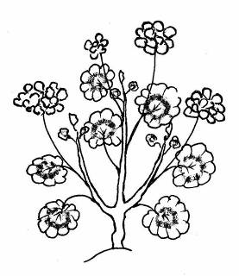 | 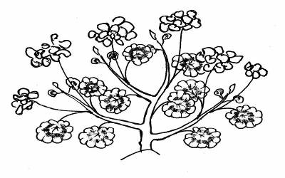 | 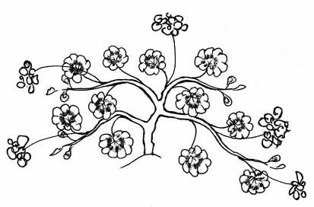
1 | 2 | 3
upright | semi-upright | trailing

Ad. 7: Leaf blade: length
Ad. 8: Leaf blade: width

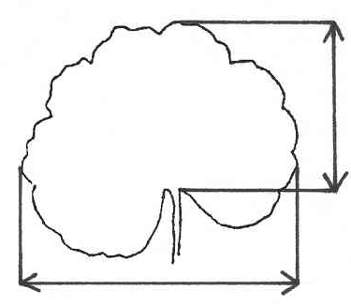
length

width

Ad. 9: Leaf blade: depth of sinus

depth of sinus

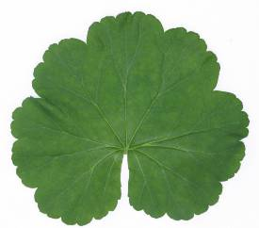
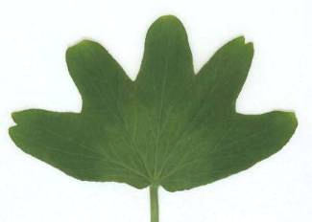

Ad. 11: Leaf blade: base

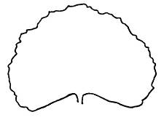 | 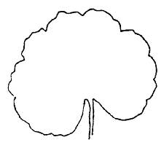 | 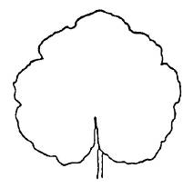 | 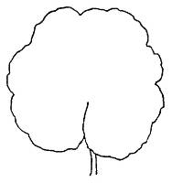 | 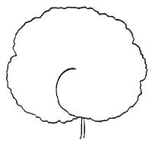
1 | 3 | 5 | 7 | 9
wide open | slightly open | closed | partly overlapping | strongly overlapping

Ad. 13: Leaf blade: main color (zone excluded)

Main color: color of the largest area of the leaf blade excluding the zone (see Ad. 16). If the area of the colors is nearly half and half, the darker color is the main color.

Ad. 14: Leaf blade: secondary color (zone excluded)

The secondary color may be the color of the variegation, if present.

Ad. 16: Leaf blade: conspicuousness of zone zone

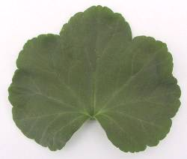 | 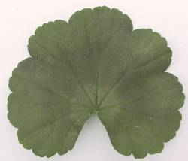 | 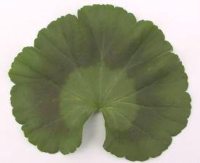 | 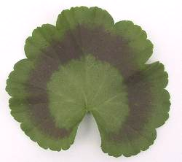 | 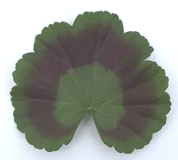
1 | 3 | 5 | 7 | 9
absent or very weak | weak | medium | strong | very strong

The conspicuousness is determined by the color contrast.
Ad. 17: Leaf blade: position of zone

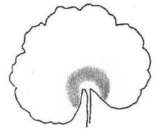 | 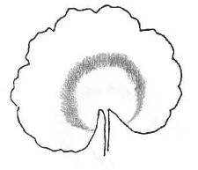 | 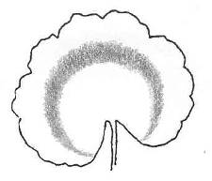
1 | 2 | 3
towards base | in middle | towards margin

The middle of the zone should be taken as the reference for the position.

Ad. 18: Leaf blade: relative size of zone

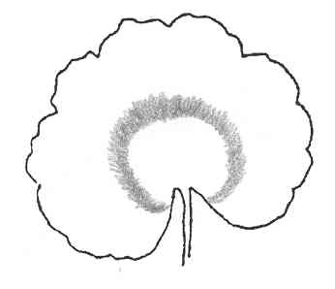 | 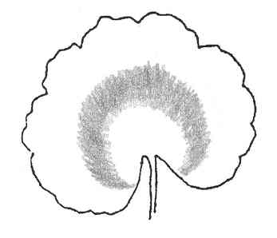 | 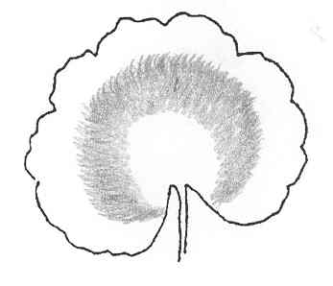
1 | 3 | 5
small | medium | large

Ad. 20: Peduncle: anthocyanin coloration of middle third

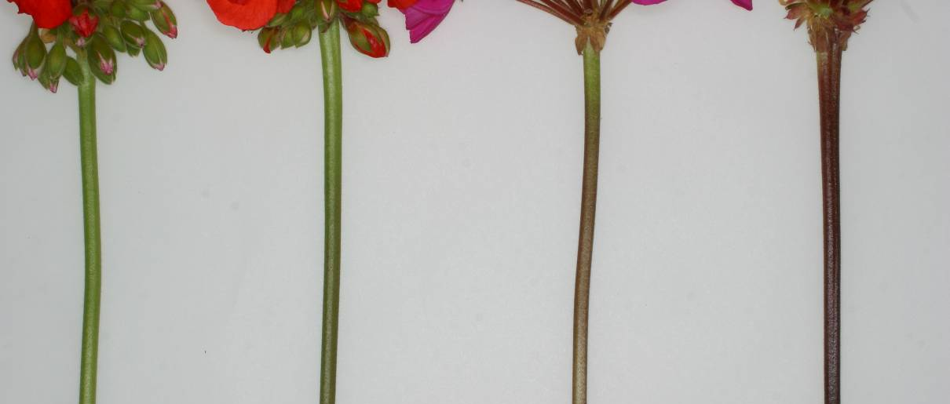

1 | 3 | 5 | 7
absent or very weak | weak | medium | strong

Ad. 21: Inflorescence: height
Ad. 22: Inflorescence: width
width
width

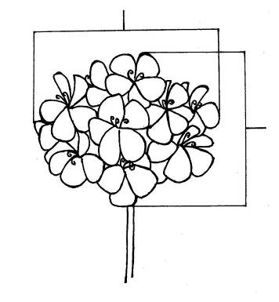
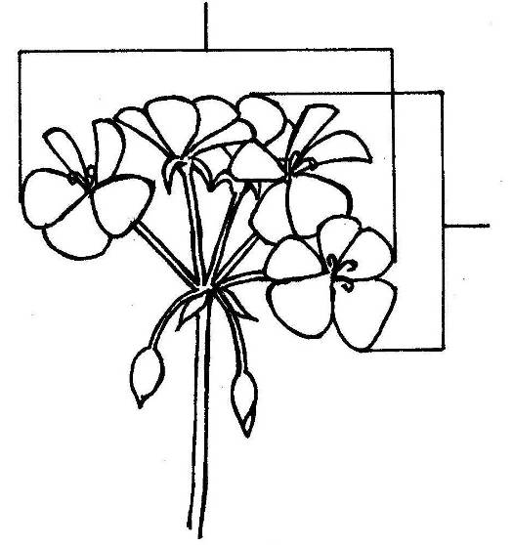

height
height

Ad. 23: Inflorescence: number of open flowers

To be observed as the number of flowers open at one time.

Ad. 24: Inflorescence: length of largest flower
Ad. 25: Inflorescence: width of largest flower
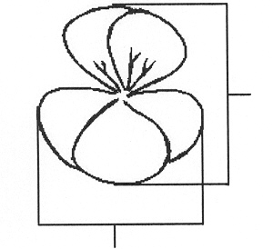

length

width

Ad. 28: Pedicel: swelling
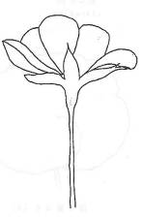
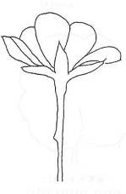

swelling

1 | 9
absent | present

In varieties where the swelling is “absent”, there may occasionally be pedicels with a swelling. In varieties where the swelling is “present”, there may occasionally be pedicels without swelling.

Ad. 29: Flower: type

A single flower has 5 petals only. A double flower has more than 5 petals.
Ad. 30: Only varieties with flower type: single: Flower: arrangement of upper petals in relation to lower petals

upper petals
lower petals
1 | 3 | 5
free | touching | moderately overlapping

Ad. 32: Flower: cross section in lateral view

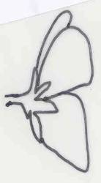 | 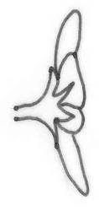 | 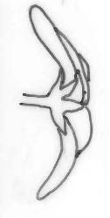
1 | 2 | 3
concave | flat | convex

Ad. 33: Flower: presence of irregularly distributed stripes or blotches

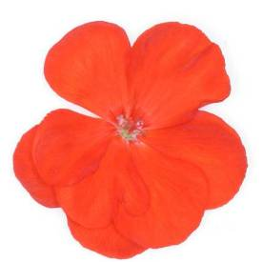 | 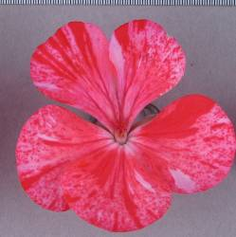
1 | 9
absent | present

Ad. 34: Only varieties with flowers with irregularly distributed stripes or blotches: Flower: main color

The main color is the color with the largest surface area, excluding irregularly distributed stripes or blotches.

Ad. 36: Sepal: reflexing

sepal

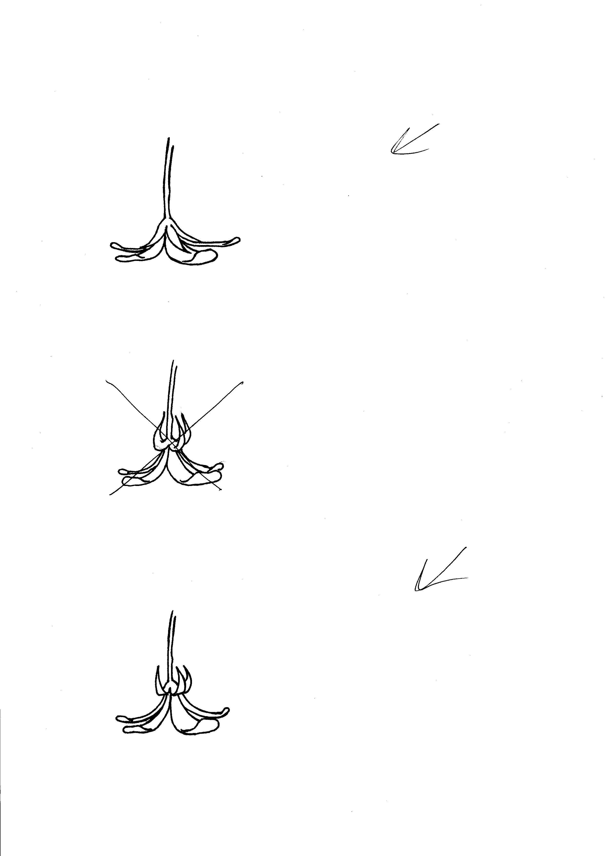
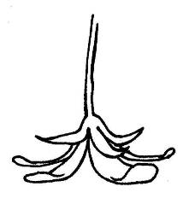

1 | 2 | 3
absent or weak | moderate | strong

Ad. 39: Upper petal: shape

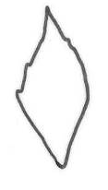 | 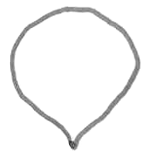 | 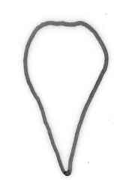 | 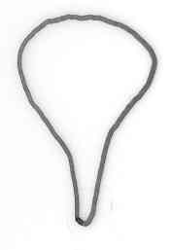
1 | 2 | 3 | 4
rhombic | round | obtriangular | spatulate

Ad. 40: Upper petal: margin of apex

 | 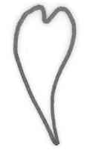 | 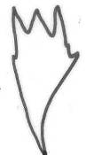
1 | 2 | 3
entire | emarginate | laciniate

Ad. 41: Upper petal: color of margin of upper side
Ad. 42: Upper petal: color of middle of upper side
Ad. 48: Upper petal: zone at base
Ad. 51: Lower petal: color of margin of upper side
Ad. 52: Lower petal: color of middle of upper side
Ad. 57: Lower petal: zone at base
color of middle
color of margin

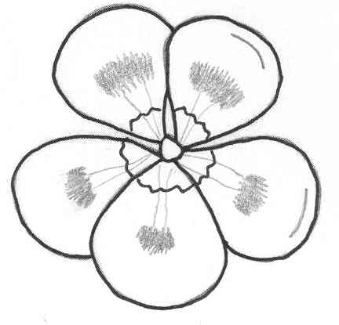
marking
upper petals

color of margin
lower petals

zone at base

Ad. 44: Upper petal: conspicuousness of marking

The conspicuousness is determined by the color contrast.

Ad. 45: Upper petal: type of marking
Ad. 55: Lower petal: type of marking

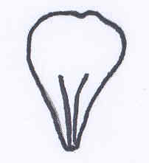 | 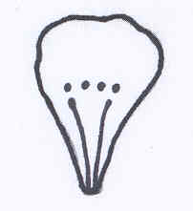 | 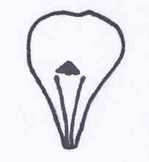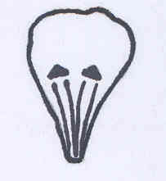 | 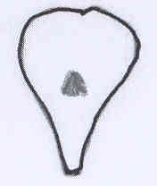
1 | 2 | 3 | 4
stripes only | stripes and dots | stripes and spot/spots | single spot only

Ad. 46: Upper petal: size of largest spot
Ad. 56: Lower petal: size of largest spot

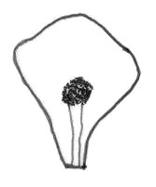 | 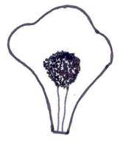 | 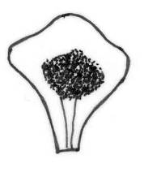
3 | 5 | 7
small | medium | large

Ad. 47: Upper petal: color of spot

Only for varieties with spot of sufficient size to use RHS Colour Chart.

Ad. 54: Lower petal: conspicuousness of marking

The conspicuousness is determined by the color contrast.

Literature
Maatsch et al, 1977: Pelargonien: Geschichte, Kultur, Wirtschaftlichkeit, Züchtung. Verlag Paul Parey, Berlin, Hamburg, DE, 116 pp.

Technical Questionnaire
TECHNICAL QUESTIONNAIRE |  |  |  | Page {x} of {y} |  | Reference Number:
 |  |  |  |  |  | Application date:
 |  |  |  |  |  | (not to be filled in by the applicant)
TECHNICAL QUESTIONNAIRE
to be completed in connection with an application for plant breeders’ rights
1. Subject of the Technical Questionnaire
1.1.1 Botanical name |  |  | Pelargonium Zonale Group  (syn. Pelargonium x hortorum L.H. Bailey) |  |  |  |  | [ ]
1.1.2 Common name |  |  | Zonal Pelargonium
1.2.1 Botanical name |  |  | Pelargonium peltatum (L.) Hér. |  |  |  |  | [ ]
1.2.2 Common name |  |  | Ivy-leaved Pelargonium
Hybrid: please indicate name(s) of species used in the crossing
1.3 Botanical name |  |  |  |  |  |  |  | [ ]
2. Applicant
Name
Address
Telephone No.
Fax No.
E-mail address
Breeder (if different from applicant)
3. Proposed denomination and breeder’s reference
Proposed denomination
(if available)

Breeder’s reference
#4. Information on the breeding scheme and propagation of the variety

4.1 Breeding scheme

Variety resulting from:

4.1.1 Crossing

(a) controlled cross [ ]
(please state parent varieties)
(b) partially known cross [ ]
(please state known parent variety(ies))
(c) unknown cross [ ]

4.1.2 Mutation [ ]
(please state parent variety)

4.1.3 Discovery and development [ ]
(please state where and when discovered and how developed)

4.1.4 Other [ ]
(please provide details)

4.2 Method of propagating the variety

4.2.1 Seed-propagated varieties

(a) Self-pollination [ ]
(b) Cross pollination
(i) population [ ]
(ii) synthetic variety [ ]
(c) Hybrid [ ]
(d) Other [ ]
(please provide details)

4.2.2 Vegetative propagation

(a) cuttings [ ]
(b) in vitro propagation [ ]
(c) other (state method) [ ]

4.2.3 Other [ ]
(please provide details)

5. Characteristics of the variety to be indicated (the number in brackets refers to the corresponding characteristic in Test Guidelines; please mark the note which best corresponds).
 | Characteristics |  |  |  |  | Example Varieties |  |  | Note
5.1  (12) | Leaf blade: variegation
 | absent |  |  |  |  | Sil Merle |  |  | 1[ ]
 | present |  |  |  |  | Penevro |  |  | 9[ ]
5.2  (13) | Leaf blade: main color (zone excluded)
 | yellow |  |  |  |  |  |  |  | 1[ ]
 | light green |  |  |  |  |  |  |  | 2[ ]
 | light green to medium green |  |  |  |  | Zowit |  |  | 3[ ]
 | medium green |  |  |  |  | Sil Merle |  |  | 4[ ]
 | medium green to dark green |  |  |  |  | KLEP03106 |  |  | 5[ ]
 | dark green |  |  |  |  | Zolirsca |  |  | 6[ ]
 | dark red |  |  |  |  | Vancouver Centennial |  |  | 7[ ]
 | brown purple |  |  |  |  | Black Magic |  |  | 8[ ]
 | other (indicate color) |  |  |  |  | ..........................................................
5.3  (16) | Leaf blade: conspicuousness of zone
 | absent or very weak |  |  |  |  | Zowit |  |  | 1[ ]
 | weak |  |  |  |  | Zolirsca |  |  | 3[ ]
 | medium |  |  |  |  | Zolarlet |  |  | 5[ ]
 | strong |  |  |  |  | Pascalpri |  |  | 7[ ]
 | very strong |  |  |  |  | Baldescarim |  |  | 9[ ]
 | Characteristics |  |  |  |  | Example Varieties |  |  | Note
5.4  (20) | Penduncle: anthocyanin coloration of middle third
 | absent or very weak |  |  |  |  | Zowit |  |  | 1[ ]
 | weak |  |  |  |  | Realcastor |  |  | 3[ ]
 | medium |  |  |  |  | Gentreo |  |  | 5[ ]
 | strong |  |  |  |  | Clips Scarl |  |  | 7[ ]
5.5  (29) | Flower: type
 | single |  |  |  |  |  |  |  | 1[ ]
 | double |  |  |  |  |  |  |  | 2[ ]
5.6  (44) | Upper petal: conspicuousness of marking
 | absent or very weak |  |  |  |  | Fisum Pink |  |  | 1[ ]
 | weak |  |  |  |  | Zoldarobo |  |  | 3[ ]
 | medium |  |  |  |  | Zonadarolo |  |  | 5[ ]
 | strong |  |  |  |  | Genda |  |  | 7[ ]
5.7  (45) | Upper petal: type of marking
 | stripes only |  |  |  |  |  |  |  | 1[ ]
 | stripes and dots |  |  |  |  |  |  |  | 2[ ]
 | stripes and spot/spots |  |  |  |  |  |  |  | 3[ ]
 | single spot only |  |  |  |  |  |  |  | 4[ ]
5.8i  (52) | Lower petal: color of middle of upper side
 | RHS Colour Chart (indicate reference number) |  |  |  |  | ……………………………………..
 | Characteristics |  |  |  |  | Example Varieties |  |  | Note
5.8ii  (52) | Lower petal: color of middle of upper side
 | white |  |  |  |  |  |  |  | 1[ ]
 | orange pink |  |  |  |  |  |  |  | 2[ ]
 | orange |  |  |  |  |  |  |  | 3[ ]
 | red |  |  |  |  |  |  |  | 4[ ]
 | purple |  |  |  |  |  |  |  | 5[ ]
 | blue pink |  |  |  |  |  |  |  | 6[ ]
 | other (indicate color) |  |  |  |  | ……………………………………..
6. Similar varieties and differences from these varieties

Please use the following table and box for comments to provide information on how your candidate variety differs from the variety (or varieties) which, to the best of your knowledge, is (or are) most similar. This information may help the examination authority to conduct ist examination of distinctness in a more efficient way.

Denomination(s) of variety(ies) similar to your candidate variety |  | Characteristic(s) in which your candidate variety differs from the similar variety(ies) |  |  | Describe the expression of the characteristic(s) for the similar variety(ies) |  | Describe the expression of the characteristic(s) for your candidate variety
Example |  | Flower: type |  |  | single |  | double
Comments:

#7. Additional information which may help in the examination of the variety

7.1 In addition to the information provided in sections 5 and 6, are there any additional characteristics which may help to distinguish the variety?

Yes [ ] No [ ]

(If yes, please provide details)

7.2 Are there any special conditions for growing the variety or conducting the examination?

Yes [ ] No [ ]

(If yes, please provide details):

7.3 Other information

A representative color photograph of the variety should accompany the Technical Questionnaire.

8. Authorization for release

(a) Does the variety require prior authorization for release under legislation concerning the protection of the environment, human and animal health?

Yes [ ] No [ ]

(b) Has such authorization been obtained?

Yes [ ] No [ ]

If the answer to (b) is yes, please attach a copy of the authorization.

9. Information on plant material to be examined or submitted for examination.

9.1 The expression of a characteristic or several characteristics of a variety may be affected by factors, such as pests and disease, chemical treatment (e.g. growth retardants or pesticides), effects of tissue culture, different rootstocks, scions taken from different growth phases of a tree, etc.

9.2 The plant material should not have undergone any treatment which would affect the expression of the characteristics of the variety, unless the competent authorities allow or request such treatment. If the plant material has undergone such treatment, full details of the treatment must be given. In this respect, please indicate below, to the best of your knowledge, if the plant material to be examined has been subjected to:

(a) Microorganisms (e.g. virus, bacteria, phytoplasma) Yes [ ] No [ ]

(b) Chemical treatment (e.g. growth retardant, pesticide) Yes [ ] No [ ]

(c) Tissue culture Yes [ ] No [ ]

(d) Other factors Yes [ ] No [ ]

Please provide details for where you have indicated “yes”.

……………………………………………………………

10. I hereby declare that, to the best of my knowledge, the information provided in this form is correct:

Applicant’s name

Signature Date

[End of document]

* These names were correct at the time of the introduction of these Test Guidelines but may be revised or updated. [Readers are advised to consult the UPOV Code, which can be found on the UPOV Website (www.upov.int), for the latest information.]
# Authorities may allow certain of this information to be provided in a confidential section of the Technical Questionnaire.
# Authorities may allow certain of this information to be provided in a confidential section of the Technical Questionnaire.

