 |  | E  TG/256/1  ORIGINAL: English  DATE: 2009-04-01
INTERNATIONAL UNION FOR THE PROTECTION OF NEW VARIETIES OF PLANTS
GENEVA

 | GRANADILLA, PASSION FRUIT  UPOV Code: PASSI_EDU  Passiflora edulis Sims | *

GUIDELINES

FOR THE CONDUCT OF TESTS

FOR DISTINCTNESS, UNIFORMITY AND STABILITY

Alternative Names:*

Botanical name | English | French | German | Spanish
Passiflora edulis Sims | Granadilla, Passion fruit | Barbadine,  Fruit de la passion | Passionsfrucht, Purpurgranadilla | Granadilla,  Maracuyá

The purpose of these guidelines (“Test Guidelines”) is to elaborate the principles contained in the General Introduction (document TG/1/3), and its associated TGP documents, into detailed practical guidance for the harmonized examination of distinctness, uniformity and stability (DUS) and, in particular, to identify appropriate characteristics for the examination of DUS and production of harmonized variety descriptions.

ASSOCIATED DOCUMENTS

These Test Guidelines should be read in conjunction with the General Introduction and its associated TGP documents.

TABLE OF CONTENTS PAGE

1. Subject of these Test Guidelines 3
2. Material Required 3
3. Method of Examination 3
3.1 Number of Growing Cycles 3
3.2 Testing Place 3
3.3 Conditions for Conducting the Examination 3
3.4 Test Design 4
3.5 Number of Plants / Parts of Plants to be Examined 4
3.6 Additional Tests 4
4. Assessment of Distinctness, Uniformity and Stability 4
4.1 Distinctness 4
4.2 Uniformity 5
4.3 Stability 5
5. Grouping of Varieties and Organization of the Growing Trial 5
6. Introduction to the Table of Characteristics 6
6.1 Categories of Characteristics 6
6.2 States of Expression and Corresponding Notes 6
6.3 Types of Expression 6
6.4 Example Varieties 6
6.5 Legend 6
7. Table of Characteristics/Tableau des caractères/Merkmalstabelle/Tabla de caracteres 7
8. Explanations on the Table of Characteristics 14
8.1 Explanations covering several characteristics 14
8.2 Explanations for individual characteristics 14
9. Literature 17
10. Technical Questionnaire 18

Subject of these Test Guidelines
These Test Guidelines apply to all varieties of Passiflora edulis Sims of the family Passifloraceae.

Material Required
2.1 The competent authorities decide on the quantity and quality of the plant material required for testing the variety and when and where it is to be delivered. Applicants submitting material from a State other than that in which the testing takes place must ensure that all customs formalities and phytosanitary requirements are complied with.

2.2 The material is to be supplied in the form of rooted cuttings or young plants.

2.3 The minimum quantity of plant material, to be supplied by the applicant, should be:

5 rooted cuttings or 5 young plants.

2.4 The plant material supplied should be visibly healthy, not lacking in vigor, nor affected by any important pest or disease.

2.5 The plant material should not have undergone any treatment which would affect the expression of the characteristics of the variety, unless the competent authorities allow or request such treatment. If it has been treated, full details of the treatment must be given.

Method of Examination

3.1 Number of Growing Cycles
3.1.1 The minimum duration of tests should normally be two independent growing cycles.

3.1.2 The growing cycle is considered to be the period ranging from the beginning of active vegetative growth or flowering, continuing through active vegetative growth or flowering and fruit development and concluding with the harvesting of fruit.

3.2 Testing Place
Tests are normally conducted at one place. In the case of tests conducted at more than one place, guidance is provided in TGP/9 “Examining Distinctness”.

3.3 Conditions for Conducting the Examination
The tests should be carried out under conditions ensuring satisfactory growth for the expression of the relevant characteristics of the variety and for the conduct of the examination. In particular, it is essential that the plants produce a satisfactory crop of fruit in each of the two growing cycles.

3.4 Test Design
3.4.1 Each test should be designed to result in a total of at least 5 plants.

3.4.2 The design of the test should be such that plants or parts of plants may be removed for measurement or counting without prejudice to the observations which must be made up to the end of the growing cycle.

3.5 Number of Plants / Parts of Plants to be Examined
Unless otherwise indicated, all observations should be made on 5 plants or parts taken from each of 5 plants. In the case of parts of plants, the number to be taken from each of the plants should be 2.

3.6 Additional Tests
Additional tests, for examining relevant characteristics, may be established.

Assessment of Distinctness, Uniformity and Stability

4.1 Distinctness

4.1.1 General Recommendations
It is of particular importance for users of these Test Guidelines to consult the General Introduction prior to making decisions regarding distinctness. However, the following points are provided for elaboration or emphasis in these Test Guidelines.

4.1.2 Consistent Differences
The differences observed between varieties may be so clear that more than one growing cycle is not necessary. In addition, in some circumstances, the influence of the environment is not such that more than a single growing cycle is required to provide assurance that the differences observed between varieties are sufficiently consistent. One means of ensuring that a difference in a characteristic, observed in a growing trial, is sufficiently consistent is to examine the characteristic in at least two independent growing cycles.

4.1.3 Clear Differences
Determining whether a difference between two varieties is clear depends on many factors, and should consider, in particular, the type of expression of the characteristic being examined, i.e. whether it is expressed in a qualitative, quantitative, or pseudo-qualitative manner. Therefore, it is important that users of these Test Guidelines are familiar with the recommendations contained in the General Introduction prior to making decisions regarding distinctness.

4.2 Uniformity
It is of particular importance for users of these Test Guidelines to consult the General Introduction prior to making decisions regarding uniformity. However, the following points are provided for elaboration or emphasis in these Test Guidelines:

For the assessment of uniformity, a population standard of 1% and an acceptance probability of at least 95% should be applied. In the case of a sample size of 5 plants, no off-types are allowed.

4.3 Stability
4.3.1 In practice, it is not usual to perform tests of stability that produce results as certain as those of the testing of distinctness and uniformity. However, experience has demonstrated that, for many types of variety, when a variety has been shown to be uniform, it can also be considered to be stable.

4.3.2 Where appropriate or in cases of doubt, stability may be tested, either by growing a further generation, or by testing a new plant stock to ensure that it exhibits the same characteristics as those shown by the previous material supplied.

Grouping of Varieties and Organization of the Growing Trial
5.1 The selection of varieties of common knowledge to be grown in the trial with the candidate varieties and the way in which these varieties are divided into groups to facilitate the assessment of distinctness are aided by the use of grouping characteristics.

5.2 Grouping characteristics are those in which the documented states of expression, even where produced at different locations, can be used, either individually or in combination with other such characteristics: (a) to select varieties of common knowledge that can be excluded from the growing trial used for examination of distinctness; and (b) to organize the growing trial so that similar varieties are grouped together.

5.3 The following have been agreed as useful grouping characteristics:

- Petiole: position of nectaries (characteristic 10)
- Fruit: ratio length/diameter (characteristic 24)
- Fruit: color of skin (characteristic 25)

Guidance for the use of grouping characteristics, in the process of examining distinctness, is provided through the General Introduction.

Introduction to the Table of Characteristics

6.1 Categories of Characteristics

6.1.1 Standard Test Guidelines Characteristics
Standard Test Guidelines characteristics are those which are approved by UPOV for examination of DUS and from which members of the Union can select those suitable for their particular circumstances.

6.1.2 Asterisked Characteristics
Asterisked characteristics (denoted by *) are those included in the Test Guidelines which are important for the international harmonization of variety descriptions and should always be examined for DUS and included in the variety description by all members of the Union, except when the state of expression of a preceding characteristic or regional environmental conditions render this inappropriate.

6.2 States of Expression and Corresponding Notes
States of expression are given for each characteristic to define the characteristic and to harmonize descriptions. Each state of expression is allocated a corresponding numerical note for ease of recording of data and for the production and exchange of the description.

6.3 Types of Expression
An explanation of the types of expression of characteristics (qualitative, quantitative and pseudo-qualitative) is provided in the General Introduction.

6.4 Example Varieties
Where appropriate, example varieties are provided to clarify the states of expression of each characteristic.

6.5 Legend
(*) Asterisked characteristic – see Chapter 6.1.2

QL Qualitative characteristic – see Chapter 6.3
QN Quantitative characteristic – see Chapter 6.3
PQ Pseudo-qualitative characteristic – see Chapter 6.3

(a)-(d) See explanations on the Table of Characteristics in Chapter 8.1
(+) See Explanations on the Table of Characteristics in Chapter 8.2

Table of Characteristics/Tableau des caractères/Merkmalstabelle/Tabla de caracteres
 |  | English | français | deutsch | español | Example Varieties/  Exemples/  Beispielssorten/  Variedades ejemplo | Note/  Nota
1.  (+) |  | Plant: color of vine | Plante : couleur de la vigne | Pflanze: Farbe der Rebe | Planta: color del tallo trepador
PQ |  | light green | vert clair | hellgrün | verde claro | Summer Queen | 1
 |  | medium green | vert moyen | mittelgrün | verde medio |  | 2
 |  | dark green | vert foncé | dunkelgrün | verde oscuro | Charité, Ester | 3
 |  | green purple | vert pourpre | grünpurpurn | púrpura verde |  | 4
 |  | purple | pourpre | purpurn | púrpura |  | 5
2. |  | Leaf blade: length | Limbe : longueur | Blattspreite: Länge | Limbo: longitud
QN | (a) | short | court | kurz | corto | Charité | 3
 |  | medium | moyen | mittel | medio | Summer Queen | 5
 |  | long | long | lang | largo | Ruby Star | 7
3.  (*) |  | Leaf blade: width | Limbe : largeur | Blattspreite: Breite | Limbo: anchura
QN | (a) | narrow | étroit | schmal | estrecho | Charité | 3
 |  | medium | moyen | mittel | medio | Summer Queen | 5
 |  | broad | large | breit | ancho | Ruby Star | 7
4. |  | Leaf blade: width of terminal lobe | Limbe : largeur du lobe terminal | Blattspreite: Breite der Endlappung | Limbo: anchura del lóbulo terminal
QN | (a) | narrow | étroit | schmal | estrecha | Charité | 3
 |  | medium | moyen | mittel | media | Summer Queen | 5
 |  | broad | large | breit | ancha | Ruby Star | 7
5.  (+) |  | Leaf blade: depth of sinus | Limbe : profondeur du sinus | Blattspreite: Tiefe der Einbuchtung | Limbo: profundidad del seno
QN | (a) | shallow | peu profond | flach | poco profundo |  | 3
 |  | medium | moyen | mittel | medio |  | 5
 |  | deep | profond | tief | profundo | Charité, Summer Queen | 7
6. |  | Leaf blade: intensity of green color | Limbe : intensité de la couleur verte | Blattspreite: Intensität der Grünfärbung | Limbo: intensidad del color verde
QN | (a) | light | claire | hell | claro |  | 3
 |  | medium | moyenne | mittel | medio | Charité | 5
 |  | dark | foncée | dunkel | oscuro | Ester | 7
7.  (*) |  | Leaf blade: blistering | Limbe : cloqûre | Blattspreite: Blasigkeit | Limbo: abullonado
QL | (a) | absent | absente | fehlend | ausente | Charité | 1
 |  | present | présente | vorhanden | presente | Marianna | 9
8. |  | Leaf blade: degree of blistering | Limbe : degré de cloqûre | Blattspreite: Stärke der Blasigkeit | Limbo: intensidad del abullonado
QN | (a) | weak | faible | gering | débil | Marianna | 3
 |  | medium | moyen | mittel | medio | Ester | 5
 |  | strong | fort | stark | fuerte |  | 7
9. |  | Petiole: length | Pétiole : longueur | Blattstiel: Länge | Pecíolo: longitud
QN | (a) | short | court | kurz | corto | Charité | 3
 |  | medium | moyen | mittel | medio | Summer Queen | 5
 |  | long | long | lang | largo | Ruby Star | 7
10.  (*)  (+) |  | Petiole: position of nectaries | Pétiole : position des nectaires | Blattstiel: Position der Nektarien | Pecíolo: posición de los nectarios
QL | (a) | adjacent to leaf blade | adjacents au limbe | an die Blattspreite anstoßend | adyacentes al limbo | Charité, IAC 273, IAC 277 | 1
 |  | distant from leaf blade | éloignés du limbe | von der Blattspreite entfernt | distantes del limbo | Summer Queen | 2
11.  (+) |  | Flower: length of  bract | Fleur : longueur de la bractée | Blüte: Länge des Deckblattes | Flor: longitud de las brácteas
QN | (b) | short | courte | kurz | cortas |  | 3
 |  | medium | moyenne | mittel | medianas | Charité | 5
 |  | long | longue | lang | largas | Summer Queen | 7
12.  (+) |  | Flower: length of  sepal | Fleur : longueur du sépale | Blüte: Länge des Kelchblattes | Flor: longitud de los sépalos
QN | (b) | short | court | kurz | cortos |  | 3
 |  | medium | moyen | mittel | medianos |  | 5
 |  | long | long | lang | largos |  | 7
13.  (+) |  | Flower: width of sepal | Fleur : largeur du sépale | Blüte: Breite des Kelchblattes | Flor: anchura de los sépalos
QN | (b) | narrow | étroit | schmal | estrechos |  | 3
 |  | medium | moyen | mittel | medianos |  | 5
 |  | broad | large | breit | anchos |  | 7
14.  (+) |  | Flower: length of petal | Fleur : longueur du pétale | Blüte: Länge des Blütenblattes | Flor: longitud de los pétalos
QN | (b) | short | court | kurz | cortos | Charité | 3
 |  | medium | moyen | mittel | medianos |  | 5
 |  | long | long | lang | largos |  | 7
15.  (+) |  | Flower: width of petal | Fleur : largeur du pétale | Blüte: Breite des Blütenblattes | Flor: anchura de los pétalos
QN | (b) | narrow | étroit | schmal | estrechos |  | 3
 |  | medium | moyen | mittel | medianos | Charité | 5
 |  | broad | large | breit | anchos |  | 7
16.  (+) |  | Flower: intensity of color of spotted ring in throat | Fleur : intensité de la couleur de l’anneau taché dans la gorge | Blüte: Intensität der Farbe des fleckigen Rings im Schlund | Flor: intensidad del color del anillo manchado en la garganta
QN | (b) | absent or light | absente ou claire | fehlend oder hell | ausente o claro |  | 1
 |  | medium | moyenne | mittel | medio | Charité | 2
 |  | dark | foncée | dunkel | oscuro |  | 3
17.  (+) |  | Flower: diameter of corona filaments | Fleur : diamètre des filaments de la partie supérieure | Blüte: Durchmesser der Kronen-staubfäden | Flor: diámetro de los filamentos de la corona
QN | (b) | small | petit | klein | pequeño | Summer Queen | 1
 |  | medium | moyen | mittel | medio | Charité | 2
 |  | large | large | groß | grande |  | 3
18.  (+) |  | Flower: presence of purple rings on corona filaments | Fleur : présence d’anneaux pourpres sur les filaments de la partie supérieure | Blüte: Vorhandensein purpurner Ringe an den Kronen-staubfäden | Flor: presencia de anillos de color púrpura en los filamentos de la corona
QL | (b) | absent | absents | fehlend | ausentes |  | 1
 |  | present | présents | vorhanden | presentes | Charité | 9
19. |  | Flower: width of purple rings on corona filaments | Fleur : largeur des anneaux pourpres sur les filaments de la partie supérieure | Blüte: Breite der purpurnen Ringe an den Kronen-staubfäden | Flor: anchura de los anillos de color púrpura en los filamentos de la corona
QN | (b) | narrow | étroite | schmal | estrechos |  | 3
 |  | medium | moyenne | mittel | medianos |  | 5
 |  | broad | large | breit | anchos |  | 7
20. |  | Flower: intensity of color of purple rings on corona filaments | Fleur : intensité de la couleur des anneaux pourpres sur les filaments de la partie supérieure | Blüte: Intensität der Farbe der purpurnen Ringe an den Kronenstaubfäden | Flor: intensidad del color púrpura de los anillos en los filamentos de la corona
QN | (b) | light | claire | hell | claro |  | 1
 |  | medium | moyenne | mittel | medio | Charité | 2
 |  | dark | foncée | dunkel | oscuro |  | 3
21.  (+) |  | Flower: spots on distal part of corona filaments | Fleur : taches sur la partie distale des filaments de la partie supérieure | Blüte: Flecken am distalen Teil der Kronenstaubfäden | Flor: manchas en la parte distal de los filamentos de la corona
QL | (b) | absent | absentes | fehlend | ausentes | Charité,  Summer Queen | 1
 |  | present | présentes | vorhanden | presentes |  | 9
22.  (*) |  | Fruit: length | Fruit : longueur | Frucht: Länge | Fruto: longitud
QN | (c) | short | court | kurz | corto | Charité | 3
 |  | medium | moyen | mittel | medio | Ester | 5
 |  | long | long | lang | largo | Ruby Star, Summer Queen | 7
23.  (*) |  | Fruit: diameter | Fruit : diamètre | Frucht: Durchmesser | Fruto: diámetro
QN | (c) | small | petit | klein | pequeño | Charité, Ester | 3
 |  | medium | moyen | mittel | medio | Ruby Star, Summer Queen | 5
 |  | large | grand | groß | grande |  | 7
24.  (*) |  | Fruit: ratio length/diameter | Fruit : rapport longueur/diamètre | Frucht: Verhältnis Länge/Durchmesser | Fruto: relación longitud/diámetro
QN | (c) | very elongated | très allongé | sehr verlängert | muy allargada | Ester | 1
 |  | elongated | allongé | verlängert | allargada |  | 3
 |  | medium | moyen | mittel | media | Ruby Star, Summer Queen | 5
 |  | compressed | comprimé | komprimiert | comprimida |  | 7
 |  | very compressed | très comprimé | sehr komprimiert | muy comprimida | Charité | 9
25.  (*) |  | Fruit: color of skin | Fruit : couleur de la peau | Frucht: Farbe der Schale | Fruto: color de la piel
PQ | (c) | yellow | jaune | gelb | amarillo | IAC 273, IAC 275, IAC 277 | 1
 |  | red | rouge | rot | rojo | Panama Red | 2
 |  | dark purple | pourpre foncé | dunkelpurpurn | púrpura oscuro | Australian purple | 3
26. |  | Fruit: conspicuousness of lenticels | Fruit : netteté des lenticelles | Frucht: Ausprägung der Lentizellen | Fruto: visibilidad de las lenticelas
QL | (c) | inconspicuous or weakly conspicuous | peu nettes ou faiblement nettes | undeutlich oder schwach deutlich | no visibles o poco visibles | Charité | 1
 |  | moderately conspicuous | modérément nettes | mittel deutlich | moderadamente visibles |  | 2
 |  | very conspicuous | très nettes | sehr deutlich | muy visibles | Marianna | 3
27. |  | Fruit: thickness of skin | Fruit : épaisseur de la peau | Frucht: Dicke der Schale | Fruto: grosor de la piel
QN | (c) | thin | fine | dünn | delgada | Charité | 3
 |  | medium | moyenne | mittel | media | Ester, Summer Queen | 5
 |  | thick | épaisse | dick | gruesa |  | 7
28. |  | Fruit: size of seed | Fruit : taille de la semence | Frucht: Größe des Samens | Fruto: tamaño de la semilla
QN | (c) | small | petite | klein | pequeña |  | 3
 |  | medium | moyenne | mittel | media | Charité, Ruby Star | 5
 |  | large | grande | groß | grande | Summer Queen | 7
29.  (+) |  | Fruit: color of funiculus | Fruit : couleur du funicule | Frucht: Farbe des Funiculus | Fruto: color del funículo
QL | (c) | white yellowish | blanc jaunâtre | weiß gelblich | blanco amarillento | Charité | 1
 |  | pink red | rose rouge | rosa rot | rosa rojo | Summer Queen | 2
30.  (+) |  | Fruit: color of pulp | Fruit : couleur de la chair | Frucht: Farbe des Fleisches | Fruto: color de la pulpa (arilo)
PQ | (c) | whitish | blanchâtre | weißlich | blanquecino |  | 1
 |  | green yellow | jaune verdâtre | grüngelb | amarillo verde |  | 2
 |  | yellow | jaune | gelb | amarillo | Charité,  IAC Paulista | 3
 |  | yellow orange | orange jaune | gelborange | amarillo anaranjado | Ester, IAC 273, Summer Queen | 4
 |  | orange | orange | orange | anaranjado | IAC 275 | 5
31.  (+) |  | Time of first harvest | Plante : époque de la première récolte | Pflanze: Zeitpunkt der ersten Erntereife | Planta: época de la primera cosecha
QN |  | early | précoce | früh | temprana | Ester | 3
 |  | medium | moyenne | mittel | media | Charité | 5
 |  | late | tardive | spät | tardía |  | 7
32.  (+) |  | Time of main harvest | Époque de la récolte principale | Zeitpunkt der Haupternte | Época de la cosecha principal
QN |  | early | précoce | früh | temprana | Charité | 3
 |  | medium | moyenne | mittel | media |  | 5
 |  | late | tardive | spät | tardía |  | 7

Explanations on the Table of Characteristics

8.1 Explanations covering several characteristics
Characteristics containing the following key in the second column of the Table of Characteristics should be examined as indicated below:

(a) Leaf blade and petiole: Observations on the leaf blade and the petiole should be made on fully developed leaves from the middle third of vigorous current-season shoots.
(b) Flower: Observations on the flower should be made on fully opened flowers.
(c) Fruit: Observations on the fruit should be made on 10 typical fruits at the time of ripeness for eating, when 30% of the surface area of the fruit has changed color.

Explanations for individual characteristics
Ad. 1: Plant: color of vine

Observations should be made on vigorous current season’s shoots.

Ad. 5: Leaf blade: depth of sinus

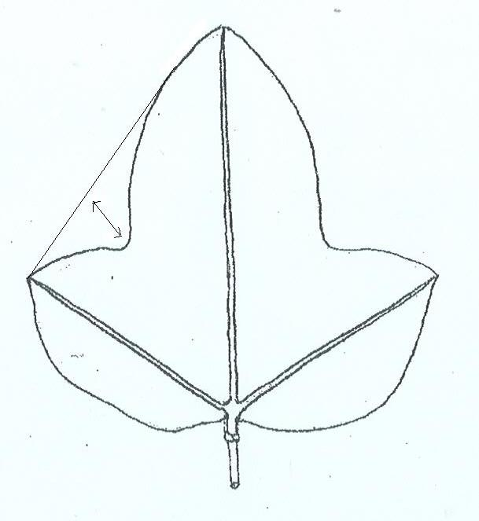 | 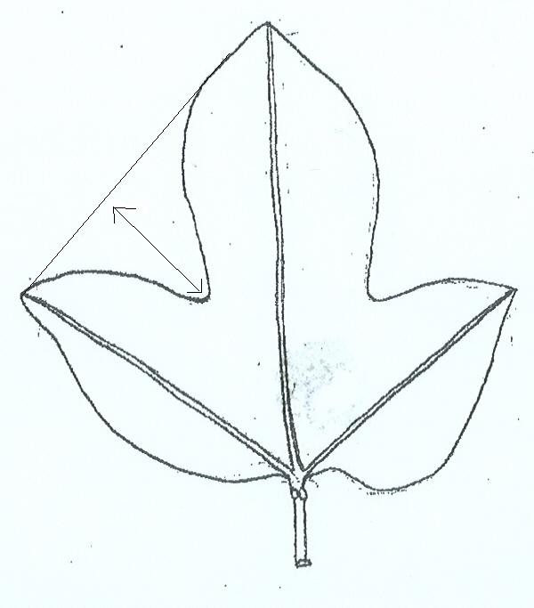 | 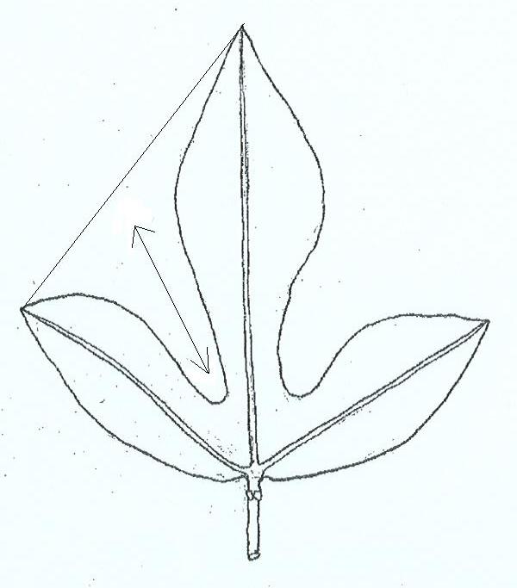
3 | 5 | 7
shallow | medium | deep

Ad. 10: Petiole: position of nectaries

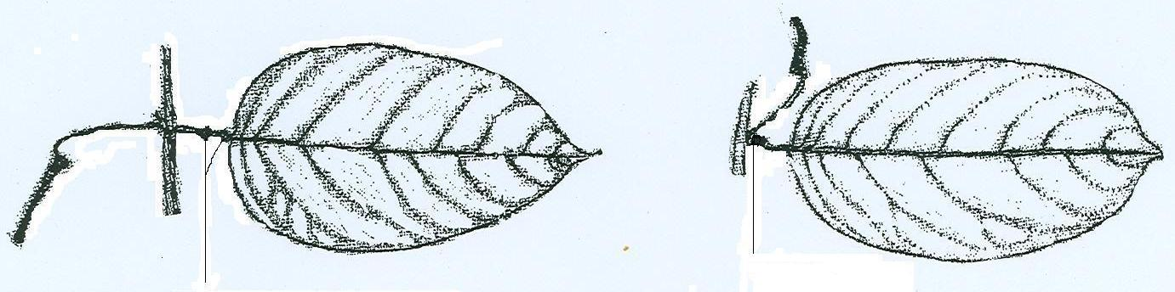
nectaries adjacent to
leaf blade
nectaries distant from
leaf blade

1 | 2
Ad. 11: Flower: length of bract
Ad. 12: Flower: length of sepal
Ad. 13: Flower: width of sepal
Ad. 14: Flower: length of petal
Ad. 15: Flower: width of petal

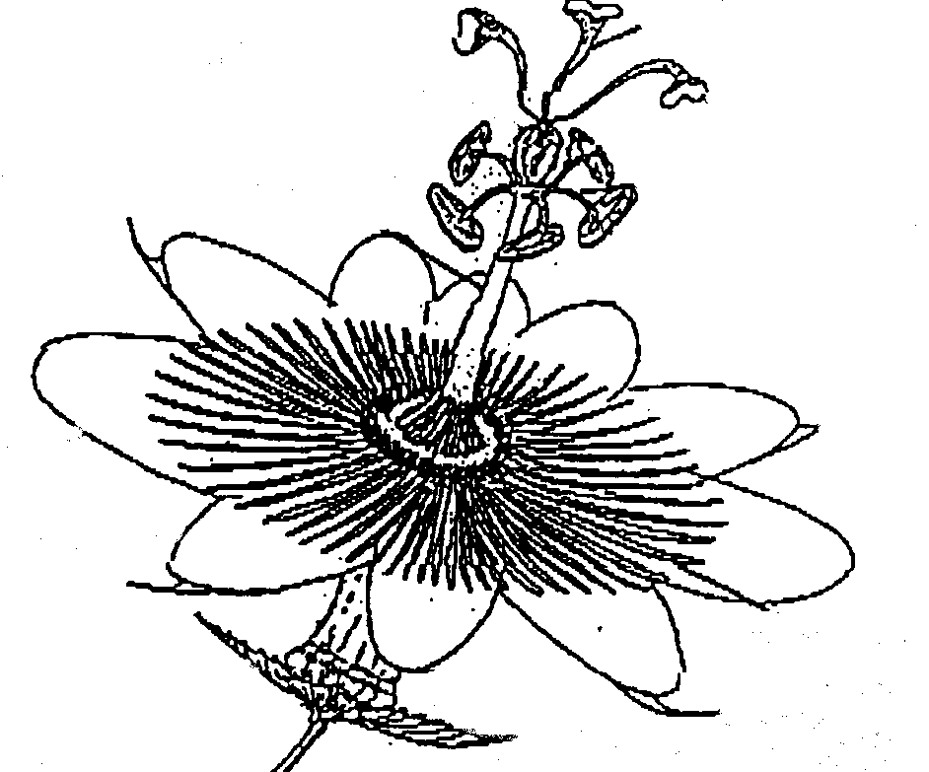
bract
sepal
petal

Length of bract: to be measured from base to distal part
Length of sepal: to be measured from base to distal part
Width of sepal: to be measured at widest point
Length of petal: to be measured from base to distal part
Width of petal: to be measured at widest point

Ad. 16: Flower: intensity of color of spotted ring in throat
Ad. 17: Flower: diameter of corona filaments
Ad. 18: Flower: presence of purple rings on corona filaments
Ad. 21: Flower: spots on distal part of corona filaments

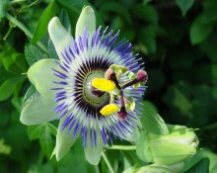
spotted ring in throat
dark spots on distal part
of corona filaments
distal part of corona filaments

purple rings on corona filaments

Ad. 29: Fruit: color of funiculus
Ad. 30: Fruit: color of pulp

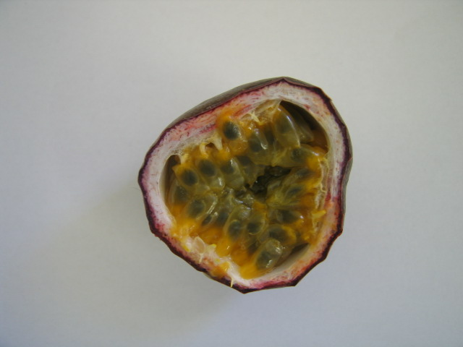
color of funiculus
color of pulp

The funiculus is the stalk attaching the ovule to the ovary wall in the fruit.

Ad. 31: Time of first harvest

Time from planting until first harvest. The time of the first harvest is when the first crop of fruit is ripe (30% of the surface of the fruit has changed color).

Ad. 32: Time of main harvest

The time of main harvest is when the largest flush of fruit is ripe (30% of the surface of the fruit has changed color).

9. Literature
Van der Plank, J., 1991: Passion Flowers and Passion Fruit. The MIT Press Cambridge, Massachusetts, US, 176 pp.

10. Technical Questionnaire
TECHNICAL QUESTIONNAIRE |  |  |  | Page {x} of {y} |  | Reference Number:
 |  |  |  |  |  | Application date:
 |  |  |  |  |  | (not to be filled in by the applicant)
TECHNICAL QUESTIONNAIRE
to be completed in connection with an application for plant breeders’ rights

1. Subject of the Technical Questionnaire
1.1 Botanical name |  |  | Passiflora edulis Sims
1.2 Common name |  |  | Granadilla, Passion fruit
2. Applicant
Name
Address
Telephone No.
Fax No.
E-mail address
Breeder (if different
from applicant)
3. Proposed denomination and breeder’s reference
Proposed denomination
(if available)
Breeder’s reference
#4. Information on the breeding scheme and propagation of the variety

4.1 Breeding scheme

Variety resulting from:

4.1.1 Crossing
(a) controlled cross [ ]
(please state parent varieties)
(b) partially known cross [ ]
(please state known parent variety(ies))
(c) unknown cross [ ]

4.1.2 Mutation [ ]
(please state parent variety)

4.1.3 Discovery and development [ ]
(please state where and when discovered and how developed)

4.1.4 Other (please provide details) [ ]

4.2 Method of propagating the variety

4.2.1 Vegetative propagation
(a) cuttings [ ]
(b) in vitro propagation [ ]
(c) other (state method) [ ]

4.2.2 Other (please provide details) [ ]

5. Characteristics of the variety to be indicated (the number in brackets refers to the corresponding characteristic in the Test Guidelines; please mark the note which best corresponds).
 | Characteristics |  |  |  |  |  | Example Varieties |  |  |  |  | Note
5.1  (7) | Leaf blade: blistering
 | absent |  |  |  |  |  | Charité |  |  |  |  | 1[ ]
 | present |  |  |  |  |  | Marianna |  |  |  |  | 9[ ]
5.2  (24) | Fruit: ratio length/diameter
 | very elongated |  |  |  |  |  | Ester |  |  |  |  | 1[ ]
 | elongated |  |  |  |  |  |  |  |  |  |  | 3[ ]
 | medium |  |  |  |  |  | Ruby Star, Summer Queen |  |  |  |  | 5[ ]
 | compressed |  |  |  |  |  |  |  |  |  |  | 7[ ]
 | very compressed |  |  |  |  |  | Charité |  |  |  |  | 9[ ]
5.3  (25) | Fruit: color of skin
 | yellow |  |  |  |  |  | IAC 273, IAC 275, IAC 277 |  |  |  |  | 1[ ]
 | red |  |  |  |  |  | Panama Red |  |  |  |  | 2[ ]
 | dark purple |  |  |  |  |  | Australian purple |  |  |  |  | 3[ ]
6. Similar varieties and differences from these varieties

Please use the following table and box for comments to provide information on how your candidate variety differs from the variety (or varieties) which, to the best of your knowledge, is (or are) most similar. This information may help the examination authority to conduct its examination of distinctness in a more efficient way.
Denomination(s) of variety(ies) similar to your candidate variety |  | Characteristic(s) in which your candidate variety differs from the similar variety(ies) |  |  | Describe the expression of the characteristic(s) for the similar variety(ies) |  |  | Describe the expression of the characteristic(s) for your candidate variety
Example |  | Fruit: color |  |  | dark purple |  |  | yellow
Comments:

#7. Additional information which may help in the examination of the variety

7.1 In addition to the information provided in sections 5 and 6, are there any additional characteristics which may help to distinguish the variety?

Yes [ ] No [ ]

(If yes, please provide details)

7.2 Are there any special conditions for growing the variety or conducting the examination?

Yes [ ] No [ ]

(If yes, please provide details)

7.3 Other information

A representative color photograph of the variety should accompany the Technical Questionnaire.

8. Authorization for release

(a) Does the variety require prior authorization for release under legislation concerning the protection of the environment, human and animal health?

Yes [ ] No [ ]

(b) Has such authorization been obtained?

Yes [ ] No [ ]

If the answer to (b) is yes, please attach a copy of the authorization.
9. Information on plant material to be examined or submitted for examination.

9.1 The expression of a characteristic or several characteristics of a variety may be affected by factors, such as pests and disease, chemical treatment (e.g. growth retardants or pesticides), effects of tissue culture, different rootstocks, scions taken from different growth phases of a tree, etc.

9.2 The plant material should not have undergone any treatment which would affect the expression of the characteristics of the variety, unless the competent authorities allow or request such treatment. If the plant material has undergone such treatment, full details of the treatment must be given. In this respect, please indicate below, to the best of your knowledge, if the plant material to be examined has been subjected to:

(a) Microorganisms (e.g. virus, bacteria, phytoplasma) Yes [ ] No [ ]

(b) Chemical treatment (e.g. growth retardant, pesticide) Yes [ ] No [ ]

(c) Tissue culture Yes [ ] No [ ]

(d) Other factors Yes [ ] No [ ]

Please provide details for where you have indicated “yes”.

……………………………………………………………

9.3 Has the plant material to be examined been tested for the presence of virus or other pathogens?

Yes [ ] No [ ]

(If yes, please provide details as specified by the Authority)

10. I hereby declare that, to the best of my knowledge, the information provided in this form is correct:

Applicant’s name

Signature Date

[End of document]

* These names were correct at the time of the introduction of these Test Guidelines but may be revised or updated. [Readers are advised to consult the UPOV Code, which can be found on the UPOV Website (www.upov.int), for the latest information.]
# Authorities may allow certain of this information to be provided in a confidential section of the Technical Questionnaire.
# Authorities may allow certain of this information to be provided in a confidential section of the Technical Questionnaire.

